
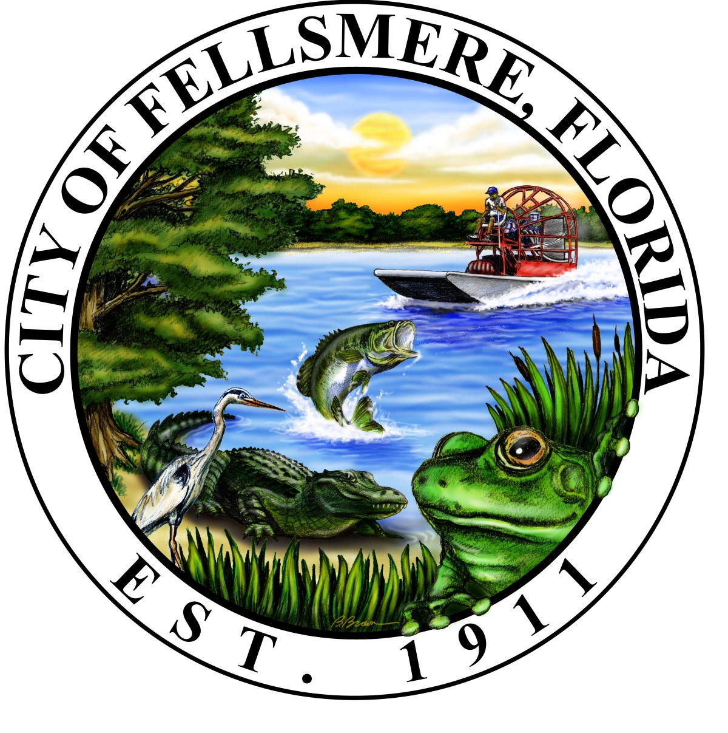
Fellsmere Day
108TH BIRTHDAY
Saturday, April 6th, 2019

PARADE ENTRY FORM
Please fill out and return as soon as possible to:
City of Fellsmere/Fellsmere Day
22 S. Orange St.
Fellsmere, FL 32948
Email: beautification107@gmail.com
Phone: Jen at (772) 453-4638 or fax to (772) 571-8615
Cut-off date: April 5th, 2019

Name of applicant/contact person: _________________________________
Name of business/ organization: ___________________________________
Physical address of business/organization:
City: ______________________ State: __________ Zip: _________
Mailing address of business/ organization: ___________________________
City: ______________________ State: __________ Zip: _________
E-mail: _______________________________________________________
Business telephone: __________________ Home telephone: ___________
Fax number: ________________

Type of entry: ____________________________ Marching/walking group: _________
Number in group: _________ Music: _________ Float: __________ Car: ___________
Other: _____________________________________ Space Required: ______________

Statement/information for the announcer to say about the entry during the parade:
________________________________________________________________________________________________________________________________________________________________________________________________________________________________________________________________________________________________

RELEASE OF LIABILITY: I hereby waive and release any and all claims for damages against the City of Fellsmere/ Fellsmere Beautification /Fellsmere Day Committee and all agents for any and all injuries suffered by participation in Fellsmere Day. I also agree to the publishing of any and all pictures from Fellsmere Day.

*SIGNATURE________________________________________ *DATE: _______________

Please check in on South Broadway St. and California Ave. at 9:00 am April 6th, 2019 for line up….
Parade Starts at 10:00am Sharp!

For more information go to: www.cityoffellsmere.org

